|  |
| --- |
| 新东方在线英语学习 |
| 新概念 1 册 |
| Lesson79-80 |



扫一扫。更多有趣的英语资讯。

1. shopping: n.购物

去购物：go shopping

购物商场：a shopping mall

看橱窗：window shopping

I really enjoy window shopping.

1. list: n.单子a name list

a shopping list 3.vegetable: n.蔬菜

Vai zhi table

veget-

vegetarian, 素食主义者

I love vegetables.

1. need: v.需要need + n.

I need some money. need + to + v.

I need to borrow some money.

1. hope: v.希望

I hope so. 希望如此。6.thing: n. 事 情 7.money: n.钱

不可数

挣钱：make money

1. I’m making a shopping list. make

# Lesson 79 单词讲解

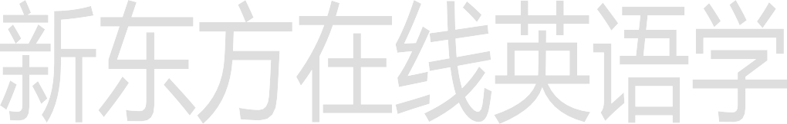**Lesson 79 课文讲解**

* 1. What make is it? n. 品牌
  2. make the bed 整理床铺
  3. make a bookcase 制作一个书架
  4. make some tea 沏茶
  5. make some coffee 冲咖啡

1. We need a lot of things this week. a lot of， 很多

many，很多（可数） much，很多（不可数） a lot of— 肯定句

1. have

= have got 拥有

We have a new house.

=We have got a new house.

We haven’t got much tea or coffee.

= We don’t have much tea or coffee. We haven’t got many tomatoes.

= We don’t have many tomatoes.

We’ve got a lot of potatoes.

=We have a lot of potatoes.

We haven’t got any meat at all.

= We don’t have any meat at all.

Have we got any beer and wine?

= Do we have any beer and wine?

I haven’t got much.

=I don’t have much.

I haven’t got much either!

= I don’t have much either!

1. We haven’t got any meat at all.

at all, 一点也不、根本，否定句

I don’t love you at all. 这根本没什么关系。It doesn't matter at all.



我跟本不认识他。

I didn't know him at all.

我根本不确定。

I'm not sure at all.

5. I hope that you’ve got some money.

have

我希望你还有钱。

that,无意义

# Lesson 79 语法讲解

1. have = have got

I have two sisters.

I have got two sisters.

1. has = has got

She has a new boyfriend. She has got a new boyfriend.

1. don’t have = haven’t got I don’t have any time.

I haven’t got any time.

1. doesn’t have = hasn’t got

She doesn’t have a good friend. She hasn’t got a good friend.

1. Do you have…? = Have you got…? Do you have any money?

Have you got any money?

1. Does she have…? = Has she got…? Does she have a boyfriend?

Has she got a boyfriend?

# Lesson 80 单词句型讲解

1. groceries: n.食品杂货

Ge rou sui yi zi

1. grocery n. 杂货店It’s a small grocery.

And there are many groceries.

1. fruit: n.水果不可数
2. stationery: n.文具

不可数

Si dei shen ne rui

1. newsagent: n.报刊零售人news, 新闻

agent,代理人，代理商，中介，经纪人5.chemist: n.化剂师，化学家

Kai mei si te

# Lesson 79&80 知识拓展

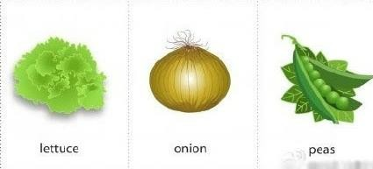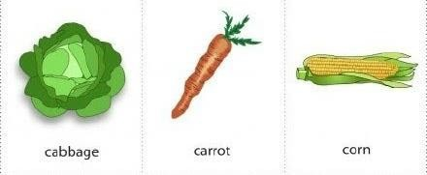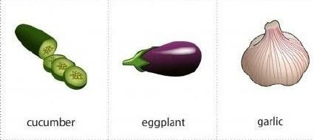

Carrot kai ruai te

Coren kao er en

Cuxcumber kui com bu er

Onion a ni n

Garlic gar lei ke